VBugs Chapter 1 Worksheet

|  |
| --- |
| **Name:** |
| **Year Level:** |

**Part 1**

Question 1

What is happening on your SwinGame screen? Describe the output below:

**Part 2**

Question 1:

* 1. What purpose do comments serve in code?

* 1. What symbol do you use to make something a comment?

* 1. Why do you think we might use NS diagrams to represent code?

* 1. What would happen to the loop the “Do Until” condition was never met?

Exercise1: *Reading the code*

1. Which line contains the code that tells the computer to

draw text on the screen?

1. Which line does contain the code that tell a computer to draw

a rectangle on the screen?

1. Where (line number) does the game loop start and end?

Exercise 2: *Changing the text*

1. Change the text "Hello World!" to "Hello *Your Name*!"

Write the code below that you changed to make this happen:

|  |
| --- |
| Answer:  …  'Draws text "Hello World"        'Refreshes the Screen and Processes Input Events  … |

Exercise 3: *Changing the color*

1. Change the color of the text to Color.GreenYellow.

Write the code below that you changed to make this happen:

|  |
| --- |
| Answer:  …  'Draws text "Hello World"      'Refreshes the Screen and Processes Input Events  … |

* 1. Change the color of the rectangle to Color.Blue.

Write the code below that you changed to make this happen:

|  |
| --- |
| Answer:  …  'Draws red rectangle    'Draws text "Hello World" |

1. Change the background color to Color.LightBlue.

Write the code below that you changed to make this happen:

|  |
| --- |
| Answer:  …  'Clears the Screen to Black      'Draws red rectangle  … |

**Part 3**

Exercise 1: *Locations on the screen*

1. 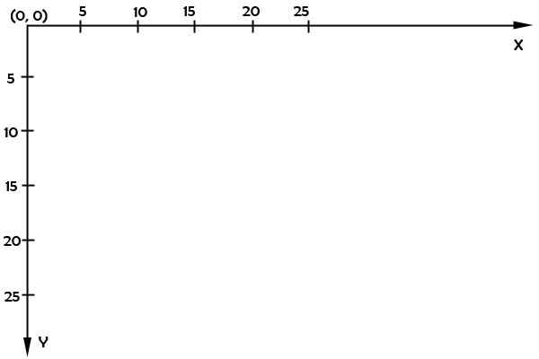In the area below draw a small rectangle with coordinates X = 15 and Y = 5 by hand.
2. In the area below draw the text “Hello Your Name” at X = 5, Y = 20.



Exercise 2: *Changing drawing locations*

1. Change the location of the text; put it in the middle of the screen.

Write the code below that you changed to make this happen:

|  |
| --- |
| Answer:  'Draws text "Hello World"      'Refreshes the Screen and Processes Input Events  … |

1. Change the location of the rectangle; put it under the text.

Write the code below that you changed to make this happen:

|  |
| --- |
| Answer:  'Draws red rectangle      'Draws text "Hello World" |

Exercise 3: *Size of an element*

1. In the area below draw a rectangle with width = 5, height = 10 at the position X = 0, Y = 5.



1. In the area below draw a rectangle with width = 10, height = 5 at the position X = 5, Y = 10.



Exercise 4: *Draw an element with the new size.*

1. Change the size of the rectangle to width = 630 and height = 20.

Write the code below that you changed to make this happen:

|  |
| --- |
| Answer:  …  'Draws red rectangle      'Draws text "Hello World" |

Exercise 5: Draw a smiley face

1. Draw a yellow circle on the screen – “face”. Use:

Graphics.FillEllipseOnScreen(Color, Xpos, Ypos, Width, Heigh)and the following dimensions:

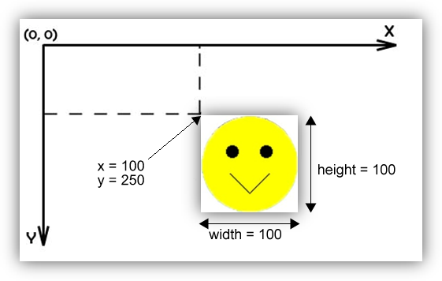

1. Draw the eyes – two black circles inside the yellow circle. Use the same sub call to draw, i.e.:

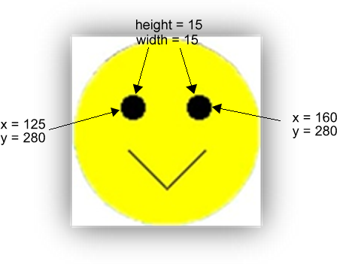

1. Draw the “smile” on the screen.

Tell the computer to draw two lines which are connected at the bottom, inside the yellow circle. To do so, use:

Graphics.DrawLineOnScreen(Color, XPosStart, YPosStart, XPosEnd, YPosEnd) i.e.:

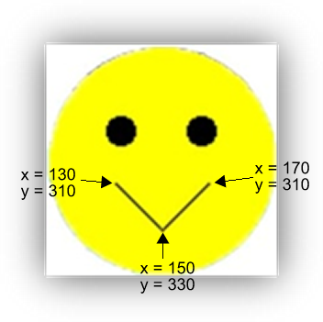

*Put the code you entered to draw the smiley face this below:*

|  |
| --- |
| 'Draw yellow circle on the screen – “face”.      'Draw eyes – two black circles inside the yellow circle      'Draw “smile” on the screen. |